Bulletin 1, 2nd November 2015

MEDITERRANEAN OPEN CHAMPIONSHIP SIVEN
12^ edition
BULGARIA – 11th-13th March 2016
MOC (stands for Mediterranean Orienteering Championship)
Born on the international experience of Park World Tour, the main circuit of international orienteering races in the historical centres and city-parks, the MOC (Mediterranean Orienteering Championship) Orienteering answered to the need of strengthen an yearly international orienteering event in the Mediterranean area. The concept of MOC was developed by Gabriele Viale following the PWT experience of Jörgen Mårtensson.

The first edition of Mediterranean open Championship took place in 2005 in Salento, with races in Carovigno, Gallipoli, Otranto and Brindisi. In March 2006 MOC was taken to Sicily and Basilicata, with stages in Palermo and Lagonegro. In March 2007 MOC was back in Puglia, hugging Bari district (In the historical centres of Bari, Altamura, Bosco della Difesa Grande of Gravina di Puglia), Salento (Torcito di Cannole Park, Carovigno) and Taranto district. In 2008 MOC staged in Policoro (Basilicata) and in Oria. In 2009 again in Taranto district. Gargano Park and the historical centres of Vico, Ischitella, Rodi and Peschici hosted the edition in 2010.

In 2011 MOC was all in Sicily, between Selinunte, Sciacca and Belice Valley. Extraordinary edition in Rome in 2012, and back in 2013 in Puglia with the final stage in Matera. 2014 MOC was held in Tuscany, Montecatini, Cecina and Florence. 2015 MOC was in Cyprus.
The special thing about MOC 2016 is that it's a first time the event will be hosted in Bulgaria and it's a first year with the main organizer being Park World Tour, with a main sponsor Siven.
Anoher treat will be the opportunity to run on Bulgaria Cup'15 maps during the MOC Camp. During the weekend the participants will have the chance to run on the same trails as SEEOC'15.
MOC SIVEN CHAMPIONSHIP 2016 Preliminary Program:

Thursday 10th March | Arrivals to Sofia, transfer to Bansko, registration, accommodation. Attention! If late arrival to Sofia, the first night will be in Sofia hotel. Dinner in Hotel
Friday 11th March | 09.30 Model event  12.00 Opening of Event Centre, registration  14.00 1st day of MOC SIVEN, sprint distance, Bansko downtown  16.30 Prize giving for the 1st stage winners  20.00 Dinner in hotel
Saturday 12th March | 10.00 2nd day of MOC SIVEN, middle distance Bansko  Free afternoon  20.00 SIVEN – MOC Bulgarian party night and prize giving for the 2nd stage winners
Sunday 13th March | 10.00 3rd day of MOC SIVEN , middle distance Bansko  Wine and food tasting at the finish area  13.00 Prize giving ceremony for the 3rd stage and overall winners  19.00 Dinner in hotel
Monday 14th March | Departures

Event Centre:
The event centre of MOC 2014 will be in Bansko.

MOC Prize Money:
SIVEN will supply the vouchers for the 3 best Elite runners in MOC Championship as following: 1° M/W 250 euro; 2° M/W 150 euro; 3° M/W 100 euro

Entry Fees and Payment Deadlines:
Within 31st December 2015: €90
Within 29th February 2016: €110
After 29th February 2016: 140€
Up to 16 years old: 50 % discount
Up to 12 years old: €30
Entry fee for MOC 2016 includes: 3 MOC races, MOC memory, wine tasting and special entertainment.
Categories:
M/W 12, M/W 14, M/W 16, M/W Junior 20, M/W 21, M/W 45, M/W 50, M/W 60, M/W 65, M/W 70, M/W 75, M/W 80, Kids, Beginners, Open 1 (like M50/W40), Open 2 (like M65/W60), Open 3 (like Beginners/M12/W12)

We will merge categories if there are few or very few entries in some categories.

Entries for MOC 2016 at the website:
www.orienteering.it > MOC 2016 > Entries and accommodations> Entries
For any question contact info@orienteering.it

Attention! For the following countries: Moldavia, Turkey, Serbia, Romania, Bulgaria, Montenegro, Greece, Macedonia, Albania, Ukraine and Russia the entry has to be sent to: info@sivenmoc.com

ACCOMMODATION:
SIVEN MOC CHAMPIONSHIP WEEKEND PACKAGE:
299€ price per person in double/twin room. Including 4 nights in half board in hotel, transport from/to races.
Extras:
+ 25€/night for single room
+ Entry fees
+ Flights to/from Sofia
If you use your rental car we reduce 10€/day
Tourist fee for not runners 25€

PWT – MOC SIVEN Sprint Camp 2016
MOC organizers welcome all the elite runners and top juniors to the 5th MOC Sprint Camp with head coach Jaroslav Kacmarcik and lecture on sports training, given by Kiril Nikolov.
What is MOC camp:
MOC camp is high-quality training camps, taking place the week before MOC Championship. Since 2011 along with MOC, it has been arranged to hold sprint training camp with top coaches. MOC Camp has been gathering athletes together from different countries and with different backgrounds. It is really satisfying and the atmosphere on MOC Camps has been truly fantastic through the years

The special thing about MOC 2016 is that it's a first time the event will be hosted in Bulgaria and it's a first year with the main organizer being Park World Tour, with a main sponsor Siven.
Anoher treat will be the opportunity to run on Bulgaria Cup'15 maps during the MOC Camp. During the weekend the participants will have the chance to run on the same trails as SEEOC'15.

7 trainings (3 sprints and 4 middle/long) on the Bulgarian sea side with a lot of orienteering and exploring local traditions. Evening party before the closure of the Camp. Further training opportunities on your request!

Additional opportunity
Extra 3 races Spring cup (2 middle and 1 sprint) on 5th and 6th March
2 days extra accommodation on 4th and 5th March

MOC SIVEN CAMP 2016 Program:
6th March 2016 | Arrivals.  15.00 Registration at the Event Centre  18.30 Dinner in hotel
7th March 2016 | 08.00 Breakfast  10.00 Training AM Middle distance in Slanchevo  12.30 Lunch at Complex Barite Long and Spa seaside resort  13.30 – 15.00 rest  15.30- 17.30 Training PM Sprint – Pobiti Kamani at Albena or Kamchia Resort  18.30 - 20.00 Dinner
8th March 2016 | 08.00 Breakfast  10.00 Training AM Long Distance in Samotino  12.30 Lunch at Complex Barite Long and Spa seaside resort  13.30 – 15.00 rest  15.30- 17.30 Training PM Sprint on the beach on Shkorpilovtzi map  18.30 - 20.00 Dinner
9th March 2016 | 08.00 Breakfast  10.00 Training AM Middle distance in Golden Sands  12.30 Lunch at Complex Barite Long and Spa seaside resort  13.30 – 15.00 rest  15.30- 17.30 Training PM Sprint at Sea garden Varna  18.30 Dinner  20.00 Closing Ceremony and “Orienteering’s night” party
10th March 2016 | Departures

SIVEN MOC CAMP package includes:
7 trainings as shown on the program, 3 competitions of MOC Championship, 8 nights accommodation (HB, 4 nights FB at Black Sea and 4 nights HB in Bansko-area) price is 349 euro

Option: MOC Sprint Camp + MOC entry fees
within 31st December 2015: € 149
within 29th February 2016: € 169
After 29th February 2016: € 189
Transports each day costs 10€ and the transfer from Varna-Bansko on March 10 can be organized (price on request).

Option:
4th March 2016 | Arrival at the airport and transfer to the training camp in Golden Sands or Kamchia resort  12.00 Opening of the Event Centre  15.30 Model training Event, close to the Event Centre  18.30 Dinner  20.00 Opening ceremony
5th March 2016 | 09.00 Breakfast  10.00 Spring cup ( middle distance) in Golden Sands  13.30 Lunch at the hotel  14.30 Departure to sprint challenge  15.00 Sprint challenge in Balchik or other park  18.00 Dinner at the hotel  20.00 “Orienteering’s night” party
6th March 2016 | 10.00 Spring cup long distance in Golden Sands  13.00 Prize giving and closing ceremony  13.30 Lunch at the hotel  17.00 Visit to the traditional Bulgarian sightseeing  18.30 Dinner at the hotel

Options:
- 3 competitions Spring cup (2 middle, 1 sprint) on 5th and 6th March: 30€
- 2 days accommodation (4th and 5th March in HB in double room + lunch package): 50€
- Transportation option 10€/day

Entries for SIVEN MOC Sprint Camp 2016 at the website:
www.orienteering.it > MOC 2016 > Entries and accommodations> Entries
For any question contact info@orienteering.it

Attention! For the following countries: Moldavia, Turkey, Serbia, Romania, Bulgaria, Montenegro, Greece, Macedonia, Albania, Ukraine and Russia the entry has to be sent to: info@sivenmoc.com

MOC TOUR 2016:
What is MOC TOUR:
MOC Tour gives an opportunity for orienteering explorers and tourists to enjoy the warmer climate while touring in new countries and getting to know the local culture. Of course, there will also be o-activities in many different places.
MOC TOUR 2016:
Bulgaria – Greece – Macedonia from March 10th to 20th/21st, 2016. For information and entries, see www.pwt.no > Orienteringreisen > MOC 2016
or http://www.pwt.no/files/MOC%20SIVEN%20Tour%202016%20preliminary%20program.pdf

Other information:
SPORTIdent-card rental:
€10 for rental of SI-card for the week + €20 for deposit. To be paid cash at the Event Centre.

Payment to:
Park World Tour Italia asd, Via Guardi, 26 35134 Padova
Bank: Banco di Brescia Branch: Padova
IBAN IT 53 D 03500 12100 0000000 23818
Swift BCABIT21385 PADOVA branch
Causal: *your name* entry MOC 2014

For any further information or questions:
Gabriele Viale, viale@orienteering.it
Julia Zenere, info@orienteering.it
For SEEOC countries, info@sivenmoc.com

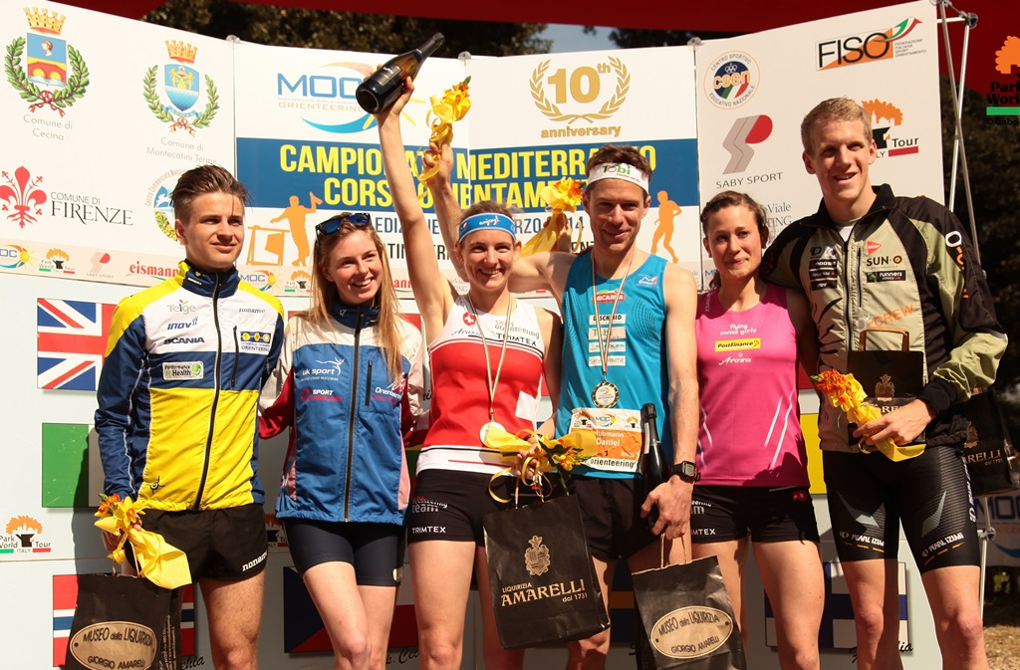

MOC winners 2014

